Section I: Scenario Demographics

Scenario Title: | Inferior STEMI with 3rd Degree Heart Block
Date of Development: | 29/AUG/2016
Target Learning Group: | Juniors (PGY 1 – 2) Seniors (PGY ≥ 3) All Groups

Section II: Scenario Developers

Scenario Developer(s): | Rob Woods
Affiliations/Institution(s): | University of Saskatchewan & Waitemata DHB, NZ
Contact E-mail (optional): | Rob.woods@usask.ca

Section III: Curriculum Integration

Learning Goals & Objectives
Educational Goal: | To review the management of acute coronary syndrome, symptomatic bradycardia and cardiac arrest.
CRM Objectives: | - Effectively lead a cardiac resuscitation.  - Implement effective communication strategies during team management:  - Task Delegation & Closed Loop Communication  - Thinking out loud & summarizing
Medical Objectives: | - Recognize inferior STEMI and heart block on ECG.  - Initiate appropriate treatment for Acute Coronary Syndrome  - Initiate appropriate treatment for symptomatic bradycardia in the setting of STEMI, including cardiac catheterization lab activation, transcutaneous pacing, and vasopressors  - Recognize cardiac arrest and provide high quality ACLS case including:  - High quality CPR (30:2 compression rate)  - Use of ETCO2 to guide resuscitation  - Minimizing pulse checks  - Appropriate 30:2 ratio of compressions to breaths prior to intubation

Case Summary: Brief Summary of Case Progression and Major Events
A 65-year-old female is brought to the ED with chest tightness and SOB. On arrival, she will be found to have an inferior STEMI with resultant 3rd degree heart block and hypotension. The team will be expected to initiate vasopressor support and transcutaneous pacing. However, prior to doing so, the patient will develop a VT arrest requiring ACLS care. After ROSC, the team will need to initiate transcutaneous pacing and activate the cath lab for definitive management.

References
Link MS, Berkow LC, Kudenchuk PJ, Halperin HR, Hess EP, Moitra VK, Neumar RW, O’Neil BJ, Paxton JH, Silvers SM, White RD. Part 7: adult advanced cardiovascular life support. Circulation. 2015 Nov 3;132(18 suppl 2):S444-64.
O’Connor RE, Al Ali AS, Brady WJ, Ghaemmaghami CA, Menon V, Welsford M, Shuster M. Part 9: acute coronary syndromes. Circulation. 2015 Nov 3;132(18 suppl 2):S483-500.

Section IV: Scenario Script

A. Scenario Cast & Realism
Patient: | Computerized Mannequin |  |  |  |  | Realism:  Select most important dimension(s) |  |  | Conceptual
 | Mannequin |  |  |  |  |  |  |  | Physical
 | Standardized Patient |  |  |  |  |  |  |  | Emotional/Experiential
 | Hybrid |  |  |  |  |  |  |  | Other:
 | Task Trainer |  |  |  |  |  |  |  | N/A
Confederates | Brief Description of Role
Bedside Nurse | Performs nursing tasks as delegated. Provides additional vitals if requested (blood sugar 6.4, Temp 37.1 ºC). Frequently describes the patient as looking pale/gray and provides ongoing cues to team regarding abnormal vitals if team is not acting on them appropriately.
B. Required Monitors
EKG Leads/Wires |  |  | Temperature Probe |  |  |  | Central Venous Line
NIBP Cuff |  |  | Defibrillator Pads |  |  |  | Capnography
Pulse Oximeter |  |  | Arterial Line |  |  |  | Other:
C. Required Equipment
Gloves |  |  | Nasal Prongs |  |  |  | Scalpel
Stethoscope |  |  | Venturi Mask |  |  |  | Tube Thoracostomy Kit
Defibrillator |  |  | Non-Rebreather Mask |  |  |  | Cricothyroidotomy Kit
IV Bags/Lines |  |  | Bag Valve Mask |  |  |  | Thoracotomy Kit
IV Push Medications |  |  | Laryngoscope |  |  |  | Central Line Kit
PO Tabs |  |  | Video Assisted Laryngoscope |  |  |  | Arterial Line Kit
Blood Products |  |  | ET Tubes |  |  |  | Bedside Ultrasound
Intraosseous Set-up |  |  | LMA |  |  |  | Other: C-spine collar
D. Moulage
Mannequin to be described or dressed as 65-year-old female who is obese (height 5’3”, weight ~ 90kg). Non-rebreather mask should be in place.

E. Approximate Timing
Set-Up: |  | 20 min |  | Scenario: | 15-20 min |  |  | Debriefing: |  | 20-30 min

Section V: Patient Data and Baseline State

A. Clinical Vignette: To Read Aloud at Beginning of Case
To be stated by the bedside nurse: “This 65-year-old woman came in with 1 hour of chest pressure and SOB. Her O2 sats were 84% on RA at triage, and they are now 90% with a non-rebreather mask. She’s also bradycardic at 30 and hypotensive at 77/40.”
B. Patient Profile and History
Patient Name: Hannah Van Vuuren |  |  |  |  |  | Age: 65 |  |  |  |  | Weight: 90kg (5’3” or 160cm)
Gender: M F |  |  |  |  |  | Code Status: Presumed full.
Chief Complaint: Chest tightness and shortness of breath
History of Presenting Illness: Husband brought her to the hospital when she started complaining of SOB and chest tightness. Well prior to 1 hour ago. She feels like someone is squeezing her chest.
Past Medical History: |  | HTN, Smoker, Dyslipidemia, Sleep Apnea |  |  |  |  | Home Medications: Cilazapril, Atorvastatin  No home CPAP (could not tolerate the machine)
Allergies: None
Social History: Lives with her husband, 1 PPD smoker for the last 45 years
Family History: None
Review of Systems: |  | CNS: |  |  | NA
 |  | HEENT: |  |  | NA
 |  | CVS: |  |  | NA
 |  | RESP: |  |  | Admitted with pneumonia last winter, frequent chest infections
 |  | GI: |  |  | NA
 |  | GU: |  |  | NA
 |  | MSK: |  |  | NA |  |  |  |  | INT: |  | Unknown.
C. Baseline Simulator State and Physical Exam
No Monitor Display |  |  |  | Monitor On, no data displayed |  |  |  |  | Monitor on Standard Display
HR: 32/min |  |  | BP: 77/40 |  |  |  | RR: 32/min |  |  |  |  | O₂SAT: 90% on NRB
Rhythm: 3rd Deg AVB |  |  | T: 37.1ºC |  |  |  | Glucose: 6.4 mmol/L |  |  |  |  | GCS: 14 (E4 V4 M6)
General Status: Sitting upright, looks distressed, having trouble answering questions, diaphoretic.
CNS: | PERLA, 3mm bilaterally.
HEENT: | Nil.
CVS: | Irregular heart sounds, no murmur. Elevated JVP.
RESP: | Tachypneic, coarse crackles throughout, accessory muscle use.
ABDO: | Nil.
GU: | Nil.
MSK: | Nil. |  |  |  |  |  |  | SKIN: | Nil.

Section VI: Case Progression
Scenario States, Modifiers and Triggers
Patient State | Patient Status | Learner Actions, Modifiers & Triggers to Move to Next State
1. Baseline State  Rhythm: 3rd degree AVB  HR: 32/min  BP: 77/40  RR: 32/min  O₂SAT: 90% NRB  T: 37.1ºC | GCS 14. | Learner Actions  - Primary Survey, coordinate team  - IV access, O2, monitors  - STAT 12 lead ECG  - Apply defib pads  - Brief history and physical exam  - IV NS 500ml bolus  - ± Portable CXR  - Call cath lab | Modifiers  Triggers  - 3 min into state  2. More Drowsy
2. More Drowsy  HR: 30/min (long 6-10 second pauses)  BP: 66/36  RR: 32/min  O₂SAT: 90% NRB | GCS, now 12/15 (E3, V3, M6). Nurse to start state by saying “she seems more drowsy.” | Learner Actions  - Atropine 0.5mg iv push  - Initiate trans-cutaneous pacing  - ± Start epinephrine infusion (2-10mcg/min)  - Consider BiPAP as bridge to intubation | Modifiers  - Atropine given no effect  Triggers  - About to initiate pacing OR 4 min into state 3. VT Arrest
3. Cardiac Arrest  Rhythm: VT  HR: 200  BP: -/-  O₂SAT: 0%  ETCO₂: 10 | Pulseless unconscious and pulseless | Learner Actions  - Immediate high quality CPR  - CPR ratio (30:2 until intubation)  - Shock VT at 200J  - Minimize peri-shock pause  - Give epinephrine 1mg IV q 3-5 minutes  - Amiodarone 300mg iv  - ± Intubation | Modifiers  - Poor quality CPR ETCO2 10 and nurse to comment  - High quality CPR ETCO2 20  Triggers  - 1 shock/2 rounds CPR  4. ROSC
4. ROSC  Rhythm: 3rd degree AVB  HR: 30  BP: 72/44  O₂SAT: 86% NRB | GCS 3. | Learner Actions  - Repeat ECG  - Atropine 0.5mg iv push  - Start epinephrine infusion (2-10mcg/min)  - Initiate trans-cutaneous pacing  - Consult Cardiology for PCI | Modifiers  - Atropine given no effect  Triggers  - Pacing initiated or epi infusion started 5. Resolution
5. Resolution  HR 80  BP 100/60  O2 Sat 94% | Unchanged. | Learner Actions  - Maintain epi infusion  - Call cath lab (if not yet done)  - Intubation to facilitate PCI  - OG insertion to administer ASA and ticagrelor  - Administer 4000 units iv heparin  - Prepare for transvenous pacemaker insertion | End Case PRN with “the cath lab is ready!”

Section VII: Supporting Documents, Laboratory Results, & Multimedia

Laboratory Results
No blood work is provided during the case.

Images (ECGs, CXRs, etc.)
ECG – Inferior STEMI with 3rd degree AV Block
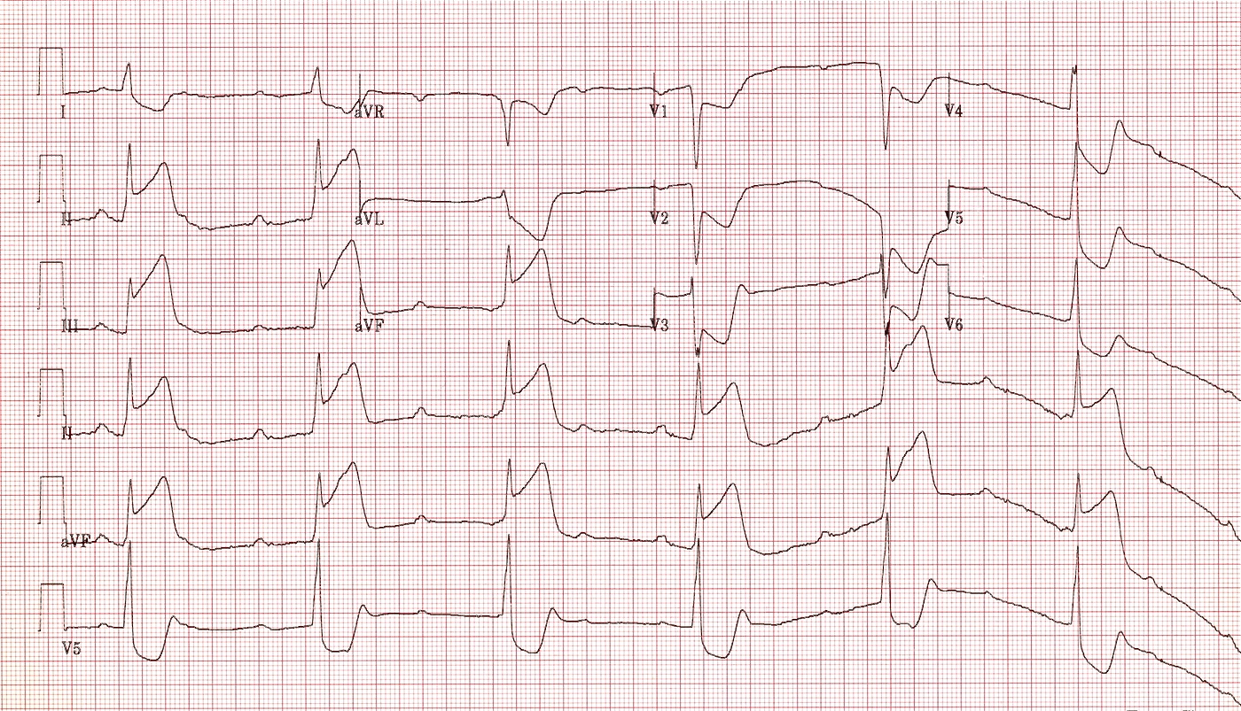
ECG source: http://lifeinthefastlane.com/ecg-library/basics/inferior-stemi/
CXR – CHF
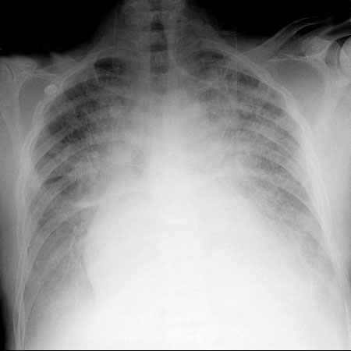
CXR source: https://www.meded.virginia.edu/courses/rad/cxr/pathology2Bchest.html

Section VIII: Debriefing Guide

General Debriefing Plan
Individual |  | Group | With Video | Without Video
Objectives
Educational Goal: | To review the management of acute coronary syndrome, symptomatic bradycardia and cardiac arrest.
CRM Objectives: | - Effectively lead a cardiac resuscitation.  - Implement effective communication strategies during team management:  - Task Delegation & Closed Loop Communication  - Thinking out loud & summarizing
Medical Objectives: | - Recognize inferior STEMI and heart block on ECG.  - Initiate appropriate treatment for Acute Coronary Syndrome  - Initiate appropriate treatment for symptomatic bradycardia in the setting of STEMI, including cardiac catheterization lab activation, transcutaneous pacing, and vasopressors  - Recognize cardiac arrest and provide high quality ACLS case including:  - High quality CPR (30:2 compression rate)  - Use of ETCO2 to guide resuscitation  - Minimizing pulse checks  - Appropriate 30:2 ratio of compressions to breaths prior to intubation
Key Prompting Questions
- Did you feel that your team leader had control over the room? Did he or she ask for input?
- What was the cause of this patient’s abnormal vitals signs and level of consciousness?
- What interventions are going to improve this patient’s status?
- When should you consider using BiPAP in the setting of heart failure?
- What can happen if you intubate and ventilate a patient whose blood pressure is quite low?
- What options are available for treating bradycardia? What do the ACLS guidelines indicate should be the initial treatments in unstable bradycardia?
Key Take Home Points
Recognition of bradycardia as complication of STEMI (and need for urgent PCI)
Management of unstable bradycardia with transcutaneous pacing and vasopressors
High quality CPR and arrest management is key to survival

